# **Conestoga Video Game Store**

# 

# **User Manual**

# Introduction

This document was written to provide step-by-step instructions in the use of the Conestoga Video Game Store website.

Contents

**User Manual** 1

Introduction 2

Navigation to Home Page 3

Basic Site Navigation 3

Registration 4

Logging into an account 6

Top Menu/Logged On Menu 7

**Finding friends/family** 8

**Removing a Friend or Family member** 9

**Wish List** 9

**Adding items to your wish list** 9

**Orders** 11

**User Profile** 12

Accessing the Store 13

**Searching the Store for items** 13

Buying an item 15

**Adding items to your cart** 15

**Checkout of the Store** 17

Reviewing an item 18

Events 19

Contact Us 20

**Contact us by email** 20

**Contact us by phone** 20

**Contact us by mail** 20

Navigation to Home Page

To access the Conestoga Video Game Store the user must have an internet enabled device and a web browser. Insert into your browser address bar: www.CVGS.com

Basic Site Navigation

Navigation points are located on the left side of the page. Highlighted by yellow box in image below.

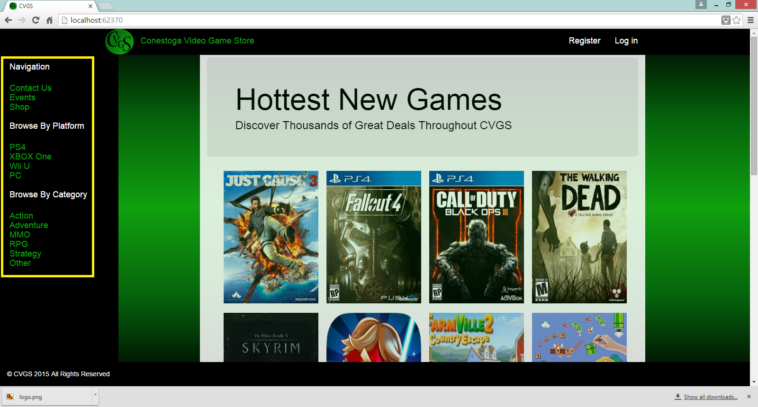

This navigation bar will always be visible no matter where you go on the Conestoga Video Game Store website so you can always quickly navigate to another area.

Registration

To register for an account the user must click the “Registration” button in the top right of the website.

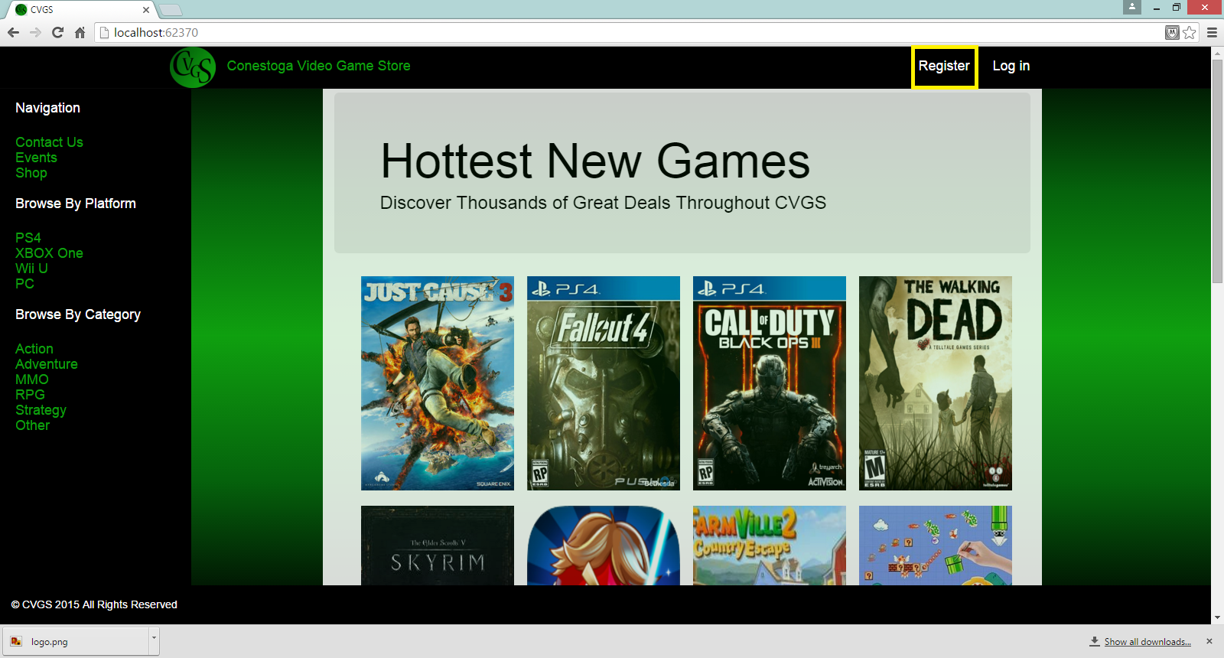

The user will then be taken to the registration form.

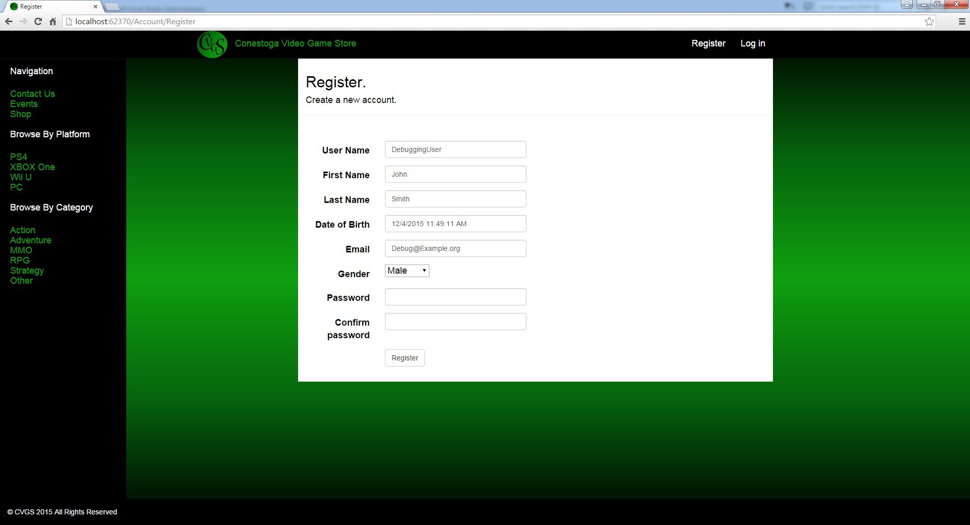

Here you will be asked to enter some basic information about yourself:

1. User Name - Your screen name that will appear for user reviews, wish lists, and any other area of the site.
2. First Name – This will be used for account and payment administration. Conestoga Video Game Store will keep this information private.
3. Last Name - This will be used for account and payment administration. Conestoga Video Game Store will keep this information private.
4. Date of birth - Refers to the date of birth of the registering user. This is account verification and for purchasing age restricted game titles. Conestoga Video Game Store will keep this information private.
5. Email – Registration requires a valid email address. It is used for password resets, to notify you of order statuses and, at your discretion send you notifications of special promotions. Conestoga Video Game Store will keep this information private.
6. Password – Your password to access your account

Important: In the event of 3 consecutive unsuccessful logins with your username, your account will be locked for 3 minutes. This is a safety feature intended to protect your account from unwanted access. If you should accidentally activate this feature, please wait for the time to pass. Your account should return to normal afterward. If you experience any difficulty please contact us (See: Contact Us) at [Support@example.com](mailto:Support@example.com)

Logging into an account

If you have already registered, you can login by clicking “Login” button at the top of the page.

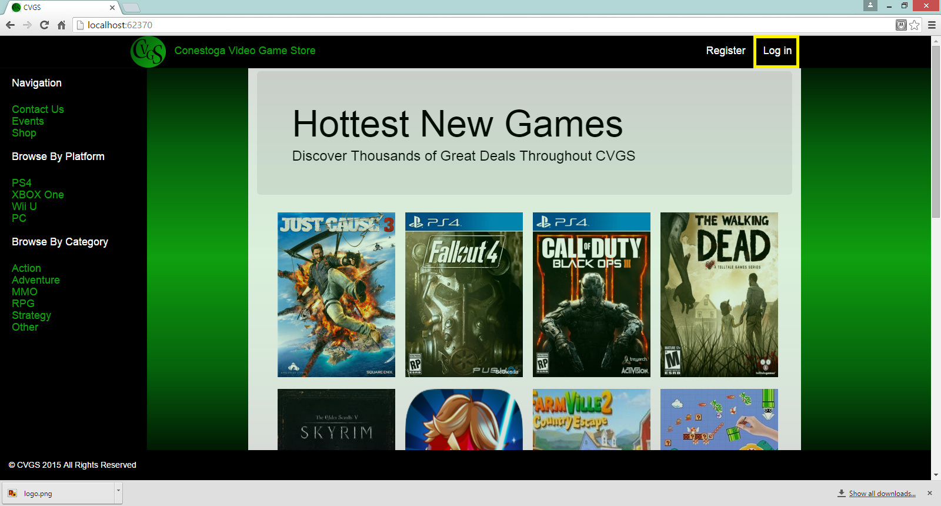

On doing so you will be prompted to enter your username and password.

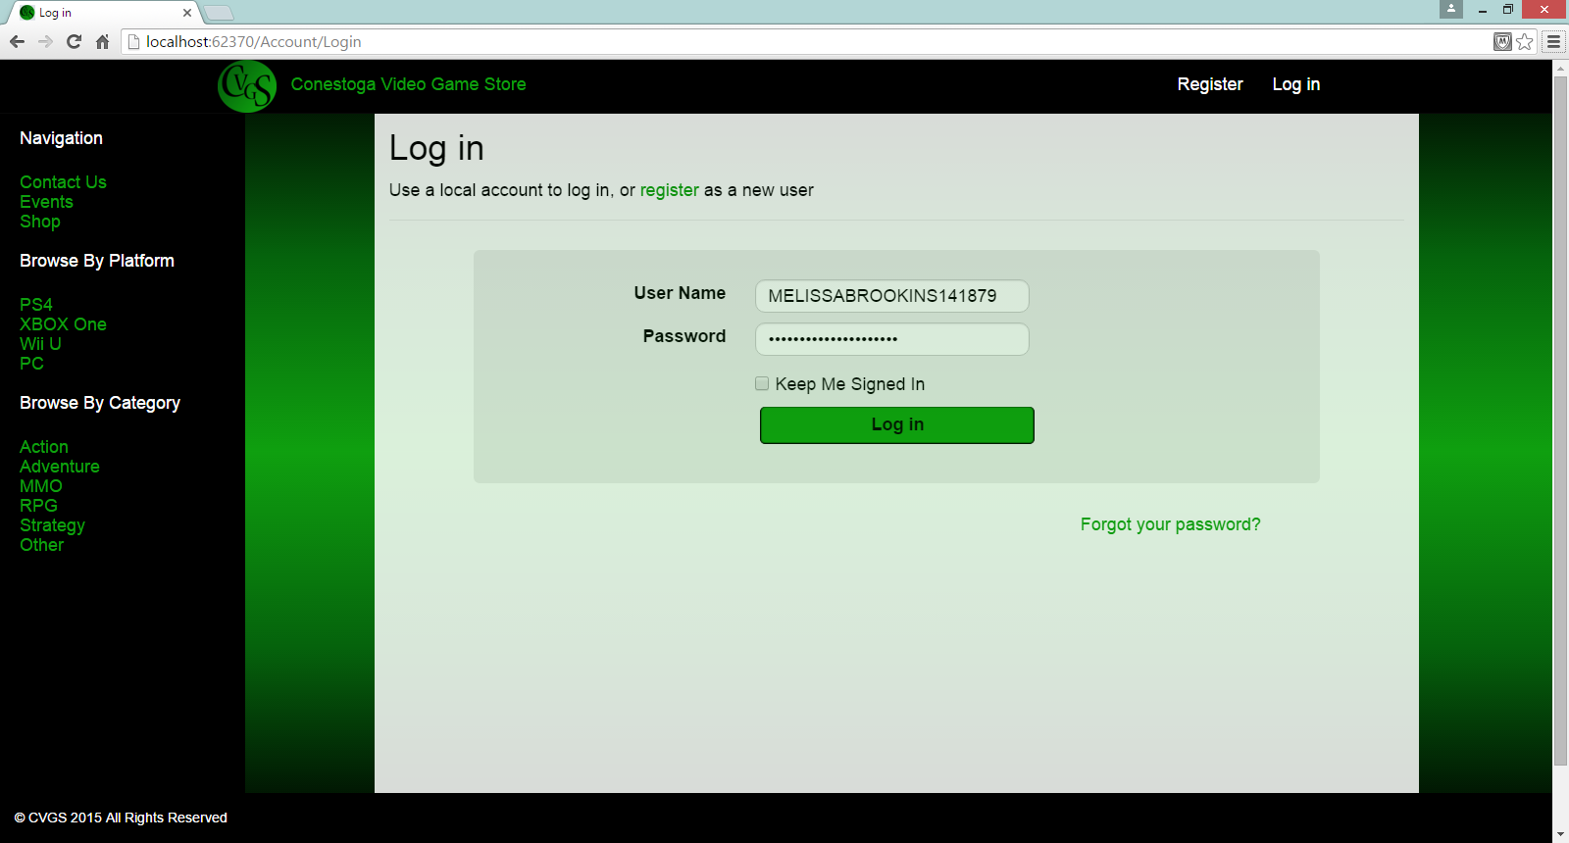

Once registered, you will be taken to your account where you can shop for and review games register for events, and manage your user profile.

Top Menu/Logged On Menu

Upon logging in you will have access to additional menu options.

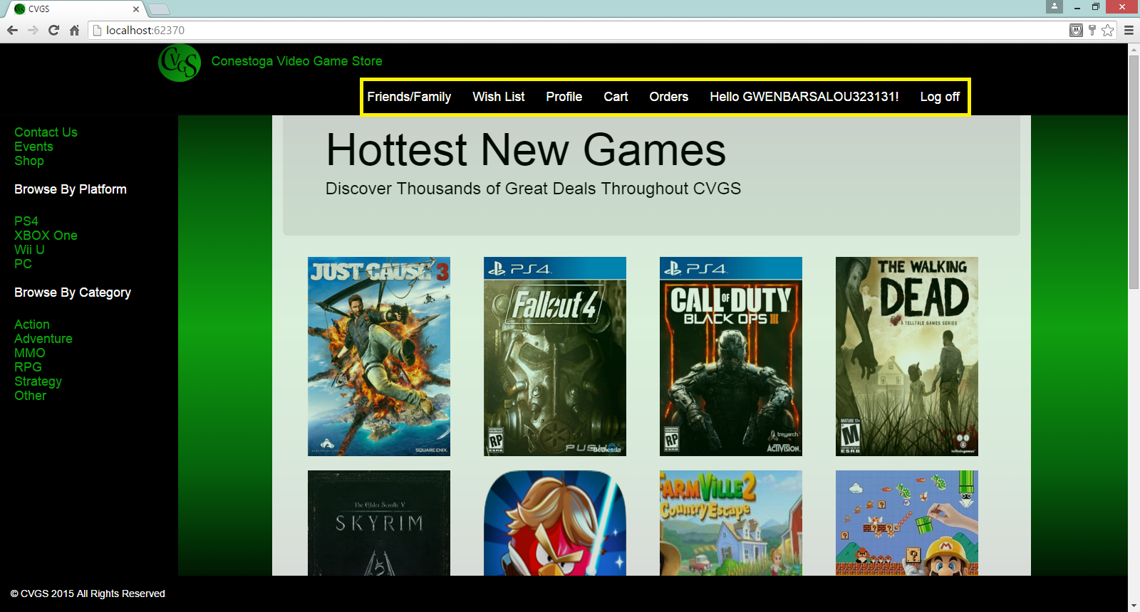

Finding friends/family

The first tab available to logged in users allows you to connect to friends and family.



When you click on the tab you will be taken to a page that will allow you to search for friends and family by name

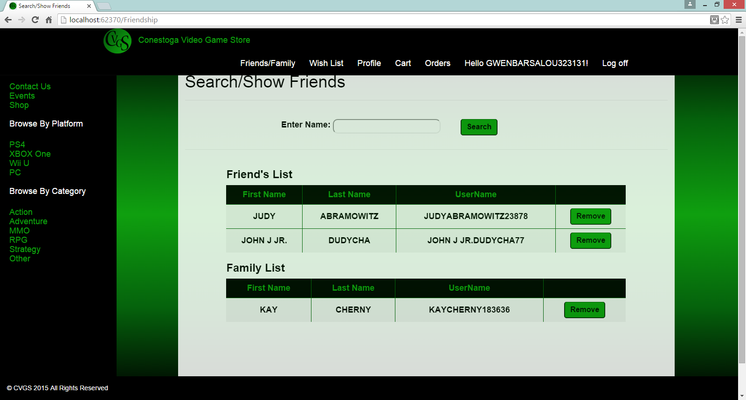.

Enter a name in the text box and click search. When results are returned you may add the chosen people to your “Friends” or “Family” list.

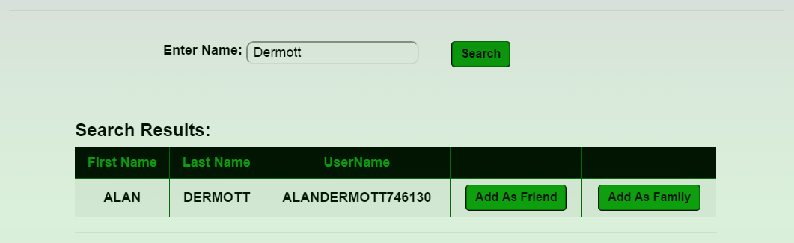

Removing a Friend or Family member

You also have the option to remove members from your friend and family list. To remove someone simply click “Remove” next to the person you wish to remove in the Friends/Family tab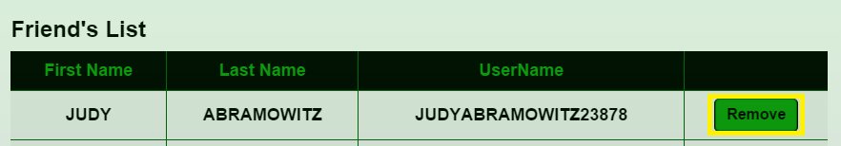

Wish List

The “Wish List” feature of the Conestoga Video Game Store allows you to keep track of items you may want to purchase. The list is also visible to your friends and family.

Adding items to your wish list

To start adding items to your wish list, search for a game (See: Searching the Store for items), click its “Details” and then click the “Add To Wishlist” button.

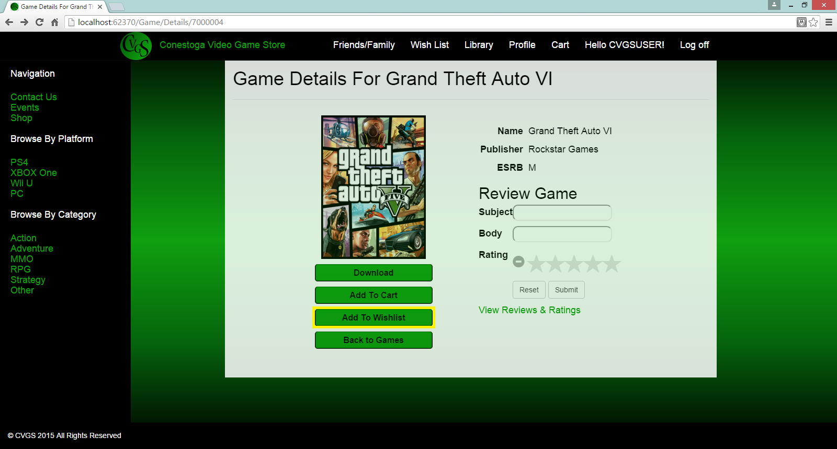

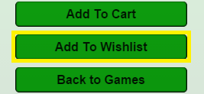

With a click, this item will be saved to your personal wish list. To view items in your wish list click “Wish List” in the top bar.



You will then be taken to your wish list items.

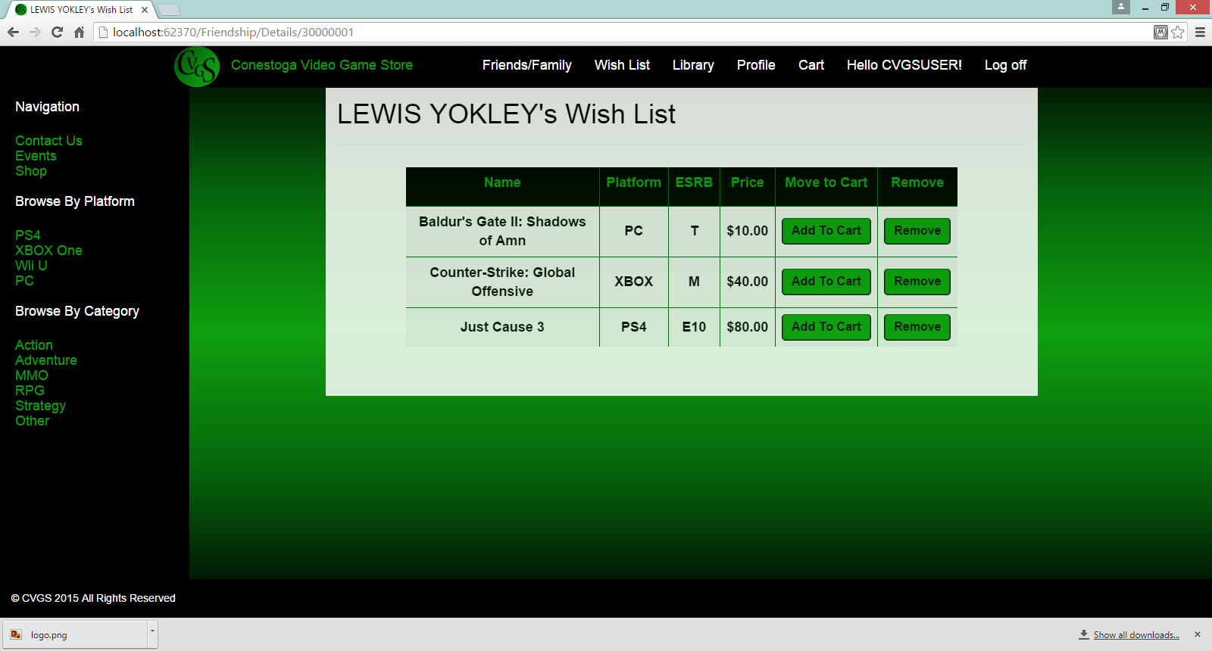

Orders

The orders tab contains a list of items you have purchased from The Conestoga Video Game Store and their status.

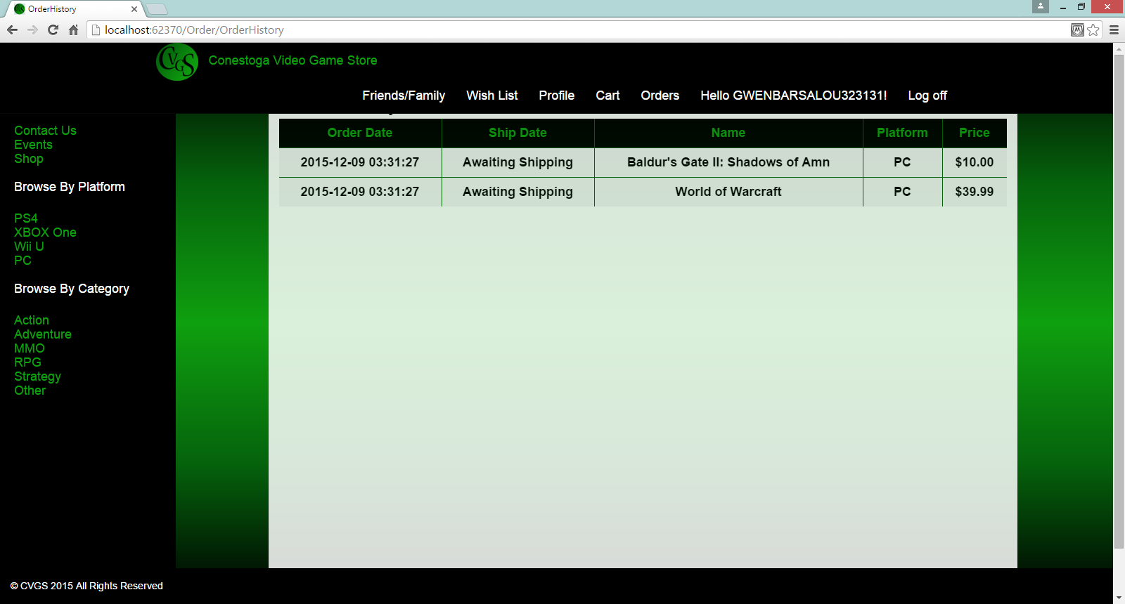

User Profile

The “Profile” button will allow you (if you are logged in) to edit your user profile.

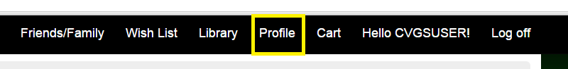

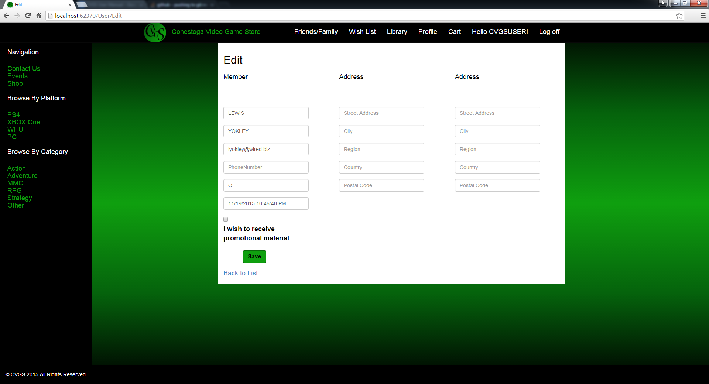

You may edit things like your name, email, phone, and also select your preference for promotional materials.

Accessing the Store

Searching the Store for items

To search for a game you may click one of the available categories on the left navigation bar.

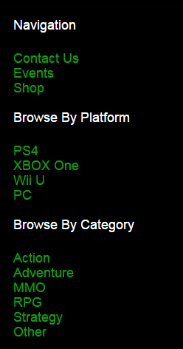

You may browse by platform or game category preference. If none of the pre defined categories interest you, you may also enter your own search criteria.

## 

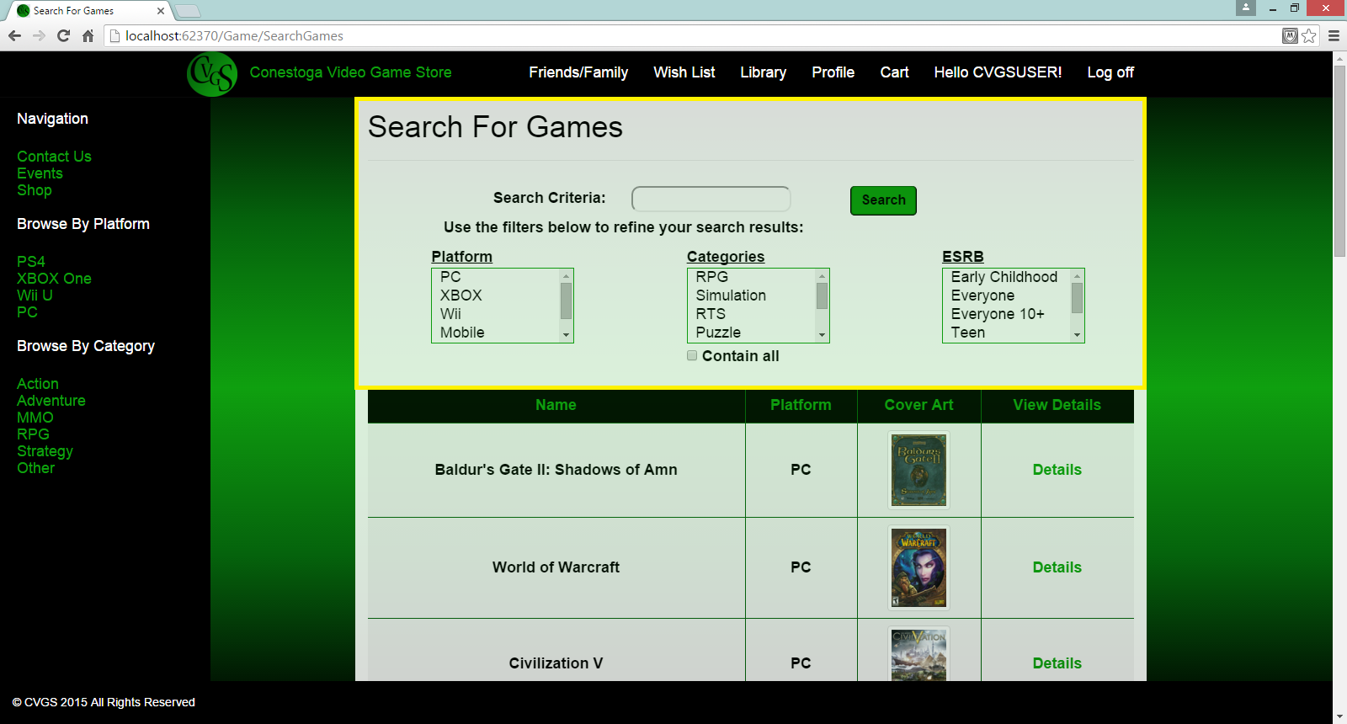

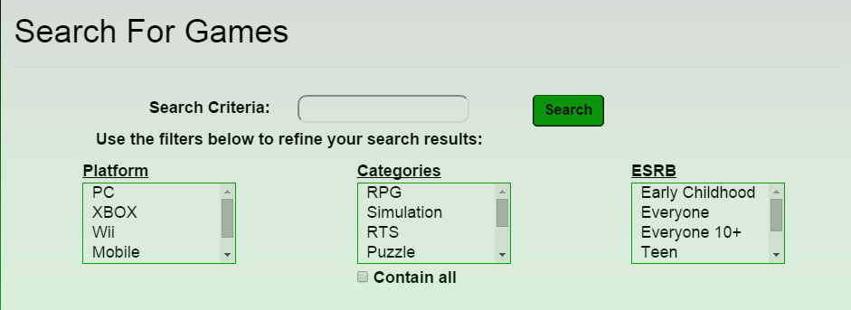

Important: To protect you from inappropriate content, you are unable to view certain content without being logged into an account or entering you age if not logged in.

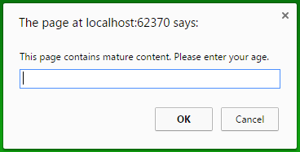

Buying an item

In order to buy an item you must be registered and logged into your user account. After locating a game that interests you (See: Searching the Store for items), you can click on the game “Details” tab to the right of the cover art in the “View Details” column and get further details about the game including purchase options.

Adding items to your cart

To add items to your cart for purchase, first search for and find a game (See: Searching the Store for items). Click the “Details” tab. You will be presented with the option “Add To Cart”

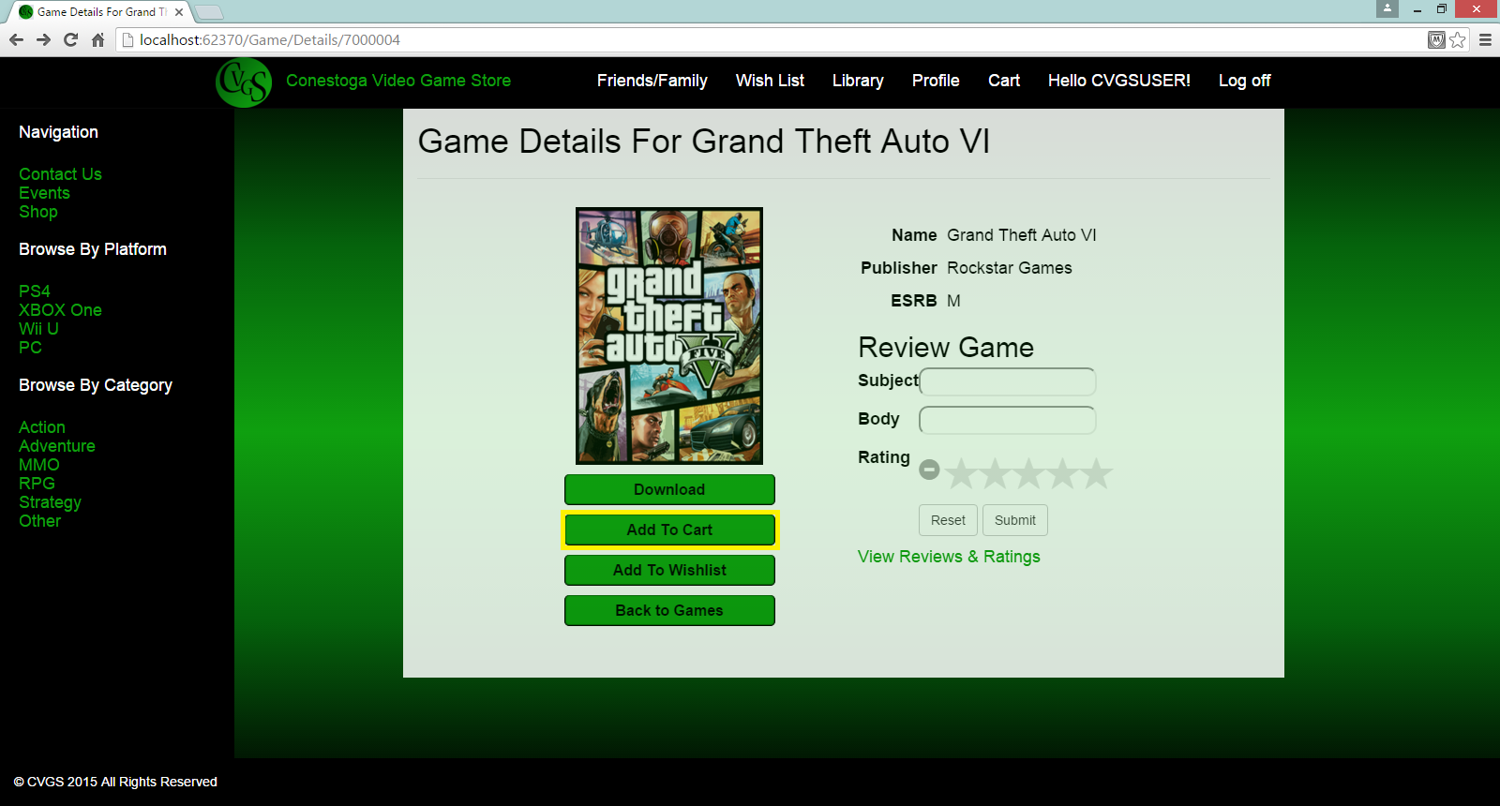

When clicked the item will then be added to your cart, which you can view by clicking the “Cart” tab in the top bar menu.



A list will be displayed of the items you have staged for purchase.

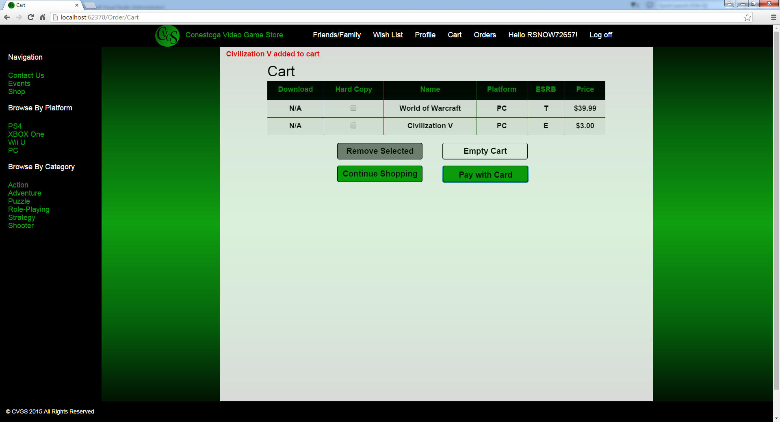

In the Cart you have options to remove items, empty the entire cart, continue shopping, or pay and checkout.

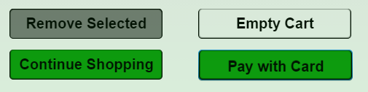

Checkout of the Store

To checkout of the store click “Pay with Card”,

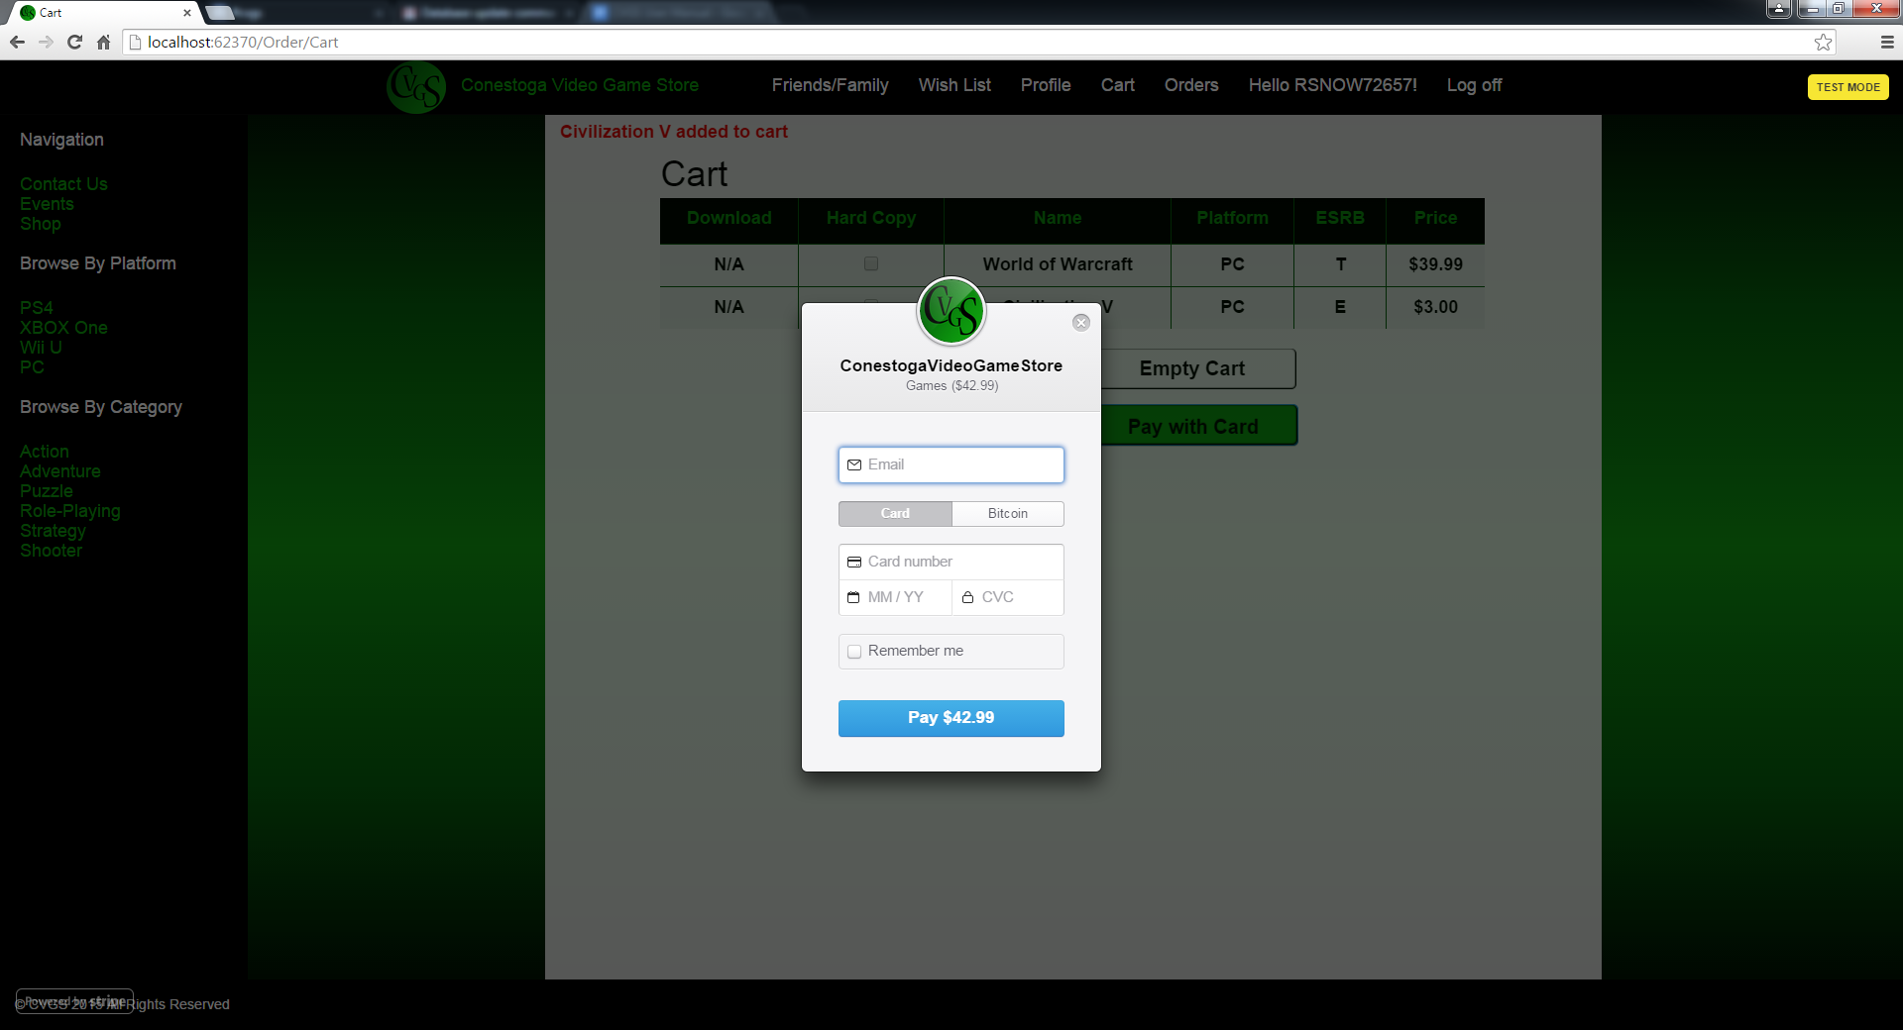

You will be prompted for an email, credit card information. On entering the information click the “Pay” button. Your order is now complete and you will receive a message of success and your order will now appear in the “Orders” tab. (See: Orders)

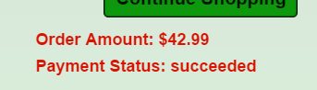

Reviewing an item

To review a game, go to its Details page and enter a subject and review in the text boxes.

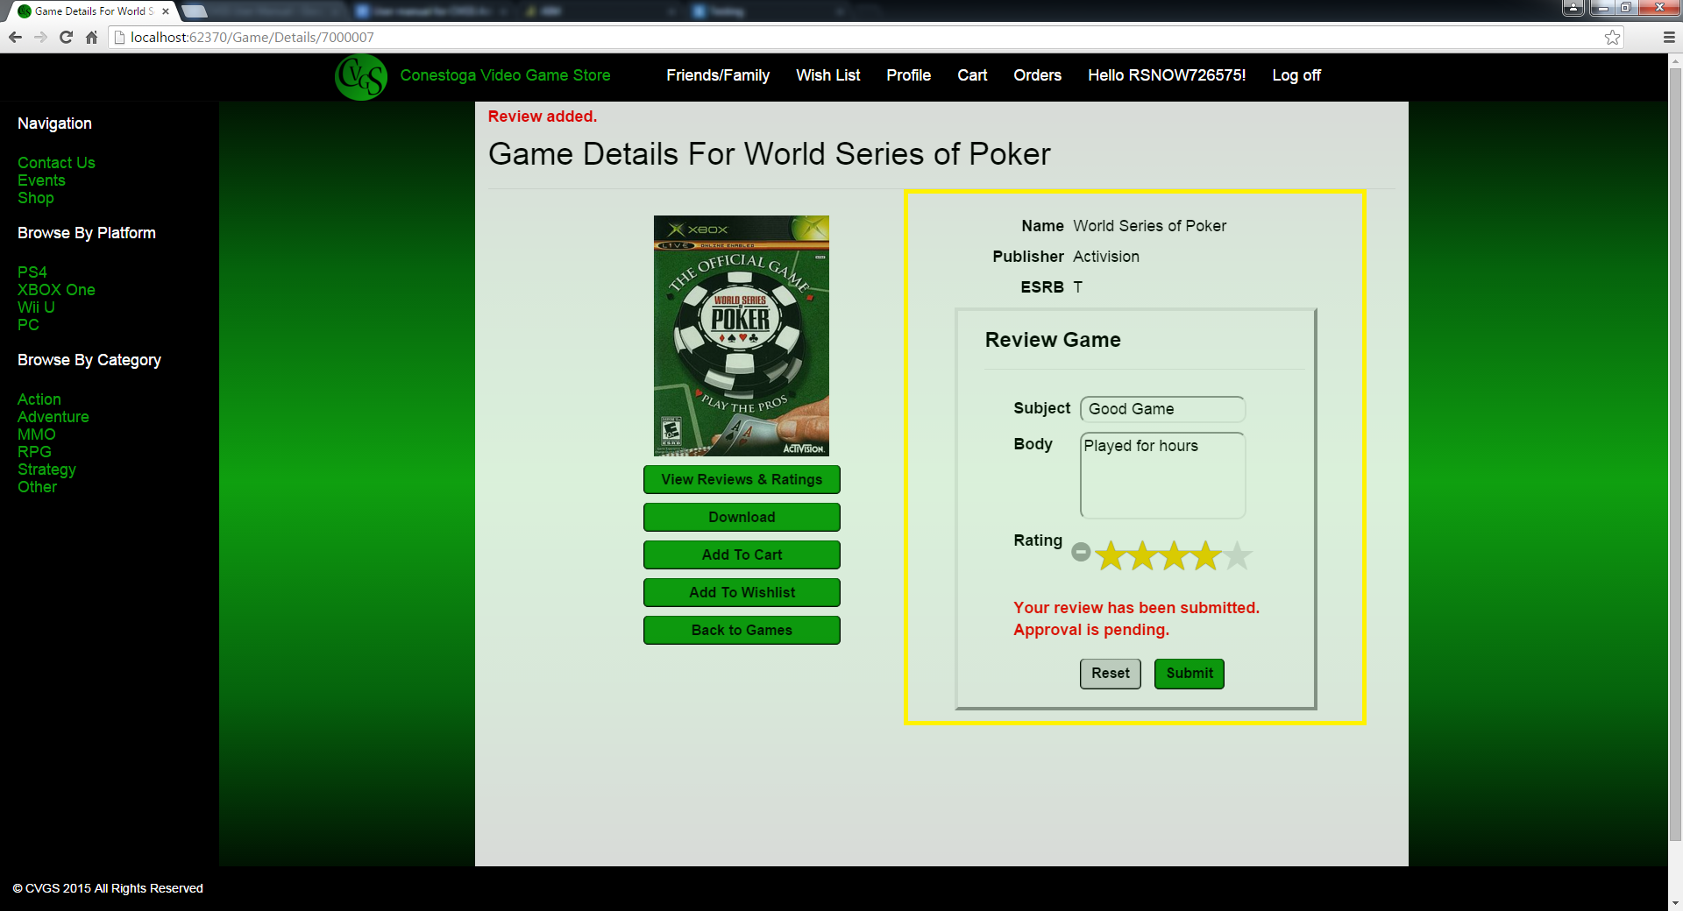

Reviews are moderated by our staff, so when you submit one you will receive the message; “Approval is pending”

To see other reviews, go to a game’s Detail View and click “View Reviews and Ratings”.

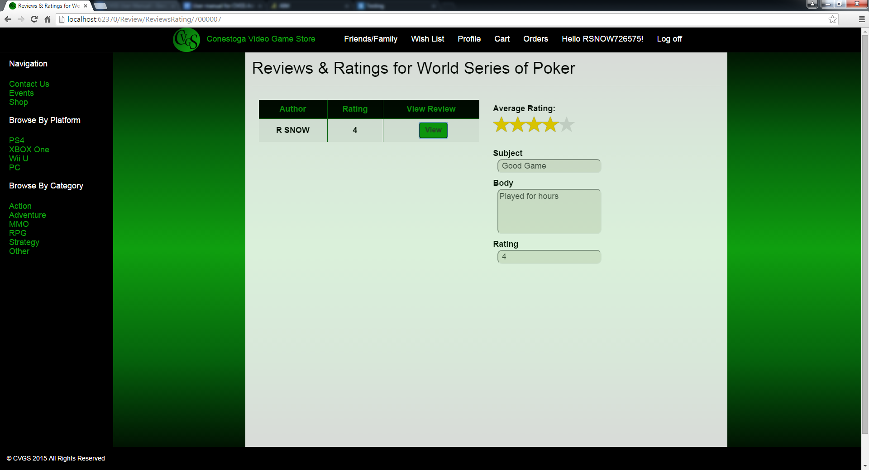

Events

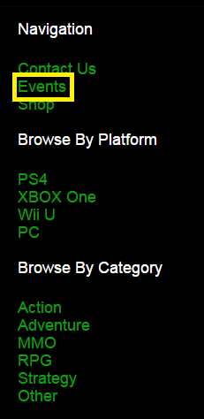Conestoga Video Game Store keeps an index of gaming events that you may register to attend.

To view a list of events click the “Events” tab in the side navigation bar.

You will be presented with a list of events to choose from.

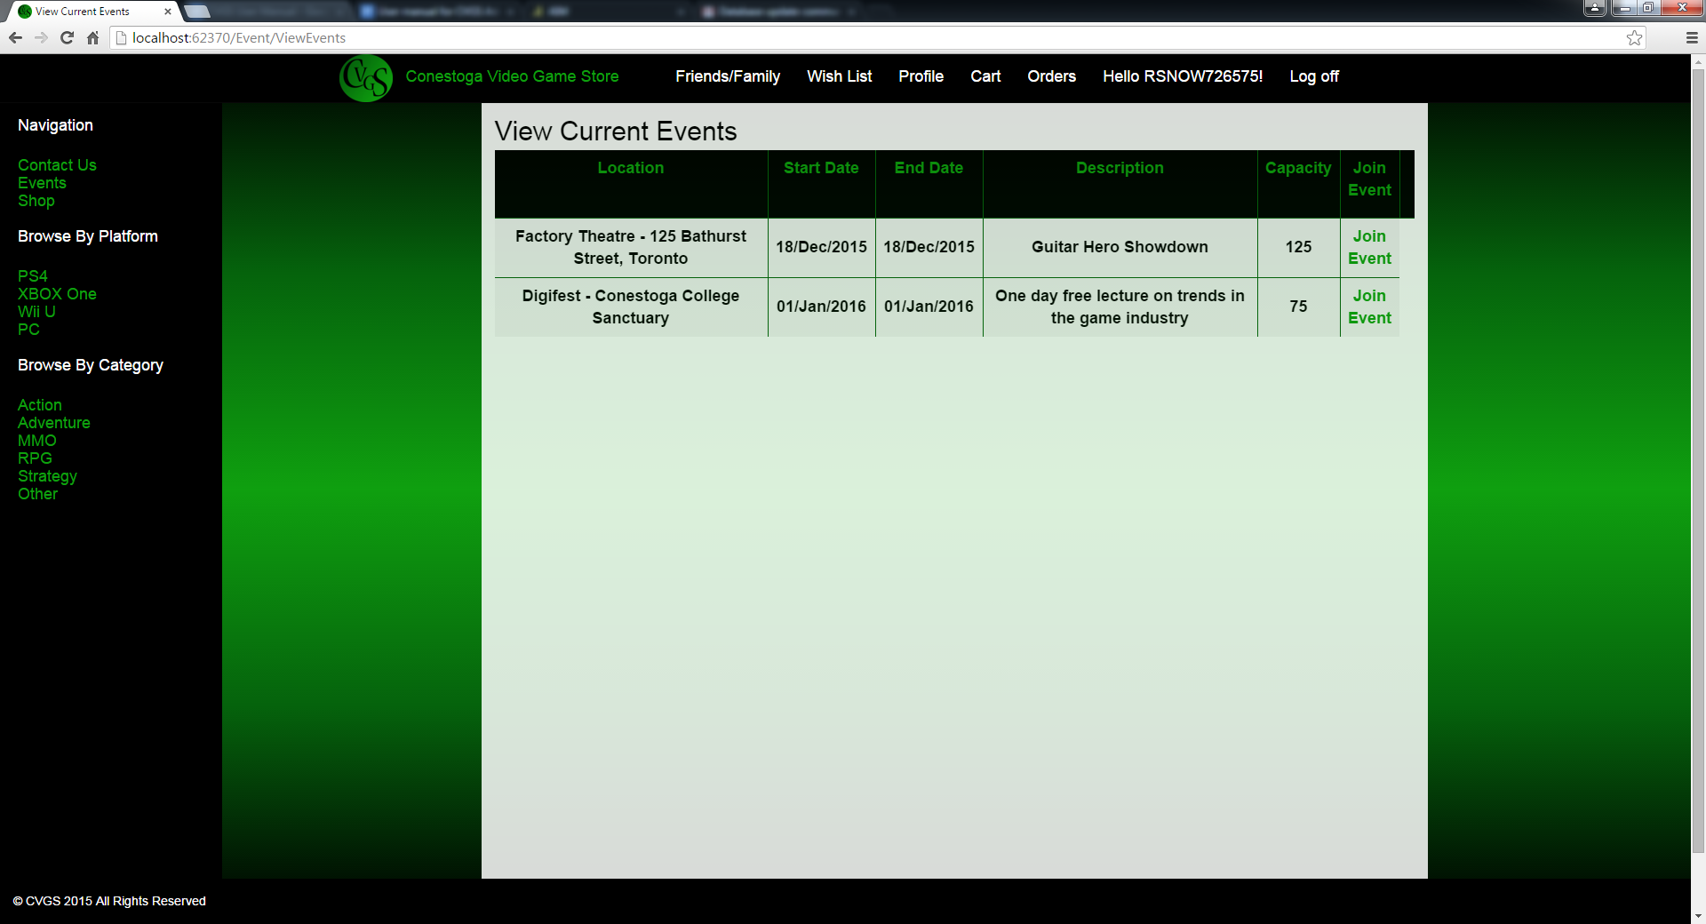

To join an event click the “Join Event” tab on the right side of the



You will get a message confirming you have joined the event at the top of your screen.

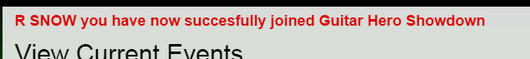

In the instance where an event is full you will receive a message alert at the top of the screen when you try to join the event

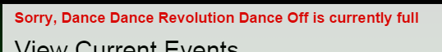

Contact Us

## **Contact us by email**

Email: <Support@example.com>

## **Contact us by phone**

Phone: 519-748-5220

## **Contact us by mail**

299 Doon Valley Drive

Kitchener, Ontario N2G 4M4, Canada